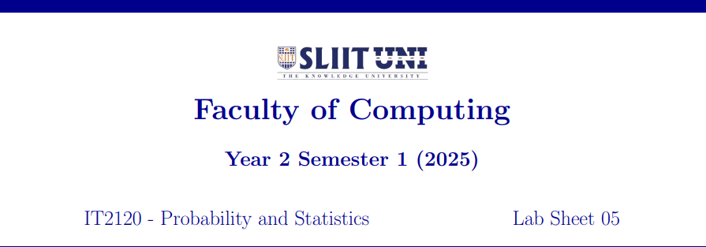

Wijesinghe.W.A.O.D

IT24100790

1.





2.





3. The distribution of delivery times is approximately symmetric and unimodal, with the peak around 35–40 minutes. It is not strongly skewed.



